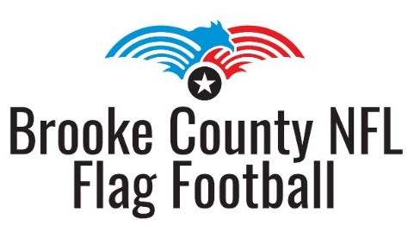
Dear Prospective Donor,
We are the Brooke County NFL Flag Football league. We are a completely volunteer run, non-profit organization that’s success relies heavily on donations from businesses and individuals in our community. In 2023, we unfortunately lost the use of our field and were unable to have our fall season. We are happy to announce that our board, with assistance from individuals like yourself, has been working hard to restore the old Jimmy Carey football stadium in Weirton. We will be ready for our 4th annual summer season this year!
Donations help us to budget for many expenses throughout the year, including:
- Field and facility maintenance
- Purchasing equipment and supplies for the concession stand
- Paying referees for each game
We have several sponsorship options listed below but any donation, no matter the size, is greatly appreciated!

Sponsor a player $120
- This covers registration and cleats for one player in need.

Rose Bowl Sponsor $200
- Your company logo will be placed on our website.
- Your company name will be listed on our league banner.
- 1 free youth registration

Sugar Bowl Sponsor $350
- Your company logo will be placed on our website.
- Your company name will be listed on our league banner.
- 1 free youth registration
- A 2.5’ x 4’ sign with your company’s information will be displayed on the fence surrounding the field.

Super Bowl Sponsor $500
- Your company logo will be placed on our website.
- Your company logo will be displayed on our league banner.
- 1 free youth registration
- A 2.5’ x 4’ sign with your company’s information will be displayed on the fence surrounding the field.
- You will receive a “Thank you” team plaque to display at your business showing your support.

Please contact Scott Vaughn at 304-650-1465 with any questions.
Checks can be made to Brooke County NFL Flag Football and mailed to PO Box 2802, Weirton, WV 26062.
EIN #86-3214157

